CPE301 – SPRING 2019

Design Assignment 3A

Student Name: Tyler Gardenhire

Student #: 8000450294

Student Email: gardenhi@unlv.nevada.edu

Primary Github address: [gardenhi@unlv.nevada.edu](mailto:gardenhi@unlv.nevada.edu)

Directory: https://github.com/tylergardenhire/submission_projects.git

Submit the following for all Labs:

1. In the document, for each task submit the modified or included code (only) with highlights and justifications of the modifications. Also, include the comments.
2. Use the previously create a Github repository with a random name (no CPE/301, Lastname, Firstname). Place all labs under the root folder ESD301/DA, sub-folder named LABXX, with one document and one video link file for each lab, place modified asm/c files named as LabXX-TYY.asm/c.
3. If multiple asm/c files or other libraries are used, create a folder LabXX-TYY and place these files inside the folder.
4. The folder should have a) Word document (see template), b) source code file(s) and other include files, c) text file with youtube video links (see template).

1. **COMPONENTS LIST AND CONNECTION BLOCK DIAGRAM w/ PINS**

Atmel Studio 7 w/ AVR assembly and simulator and Atmega328p board used.

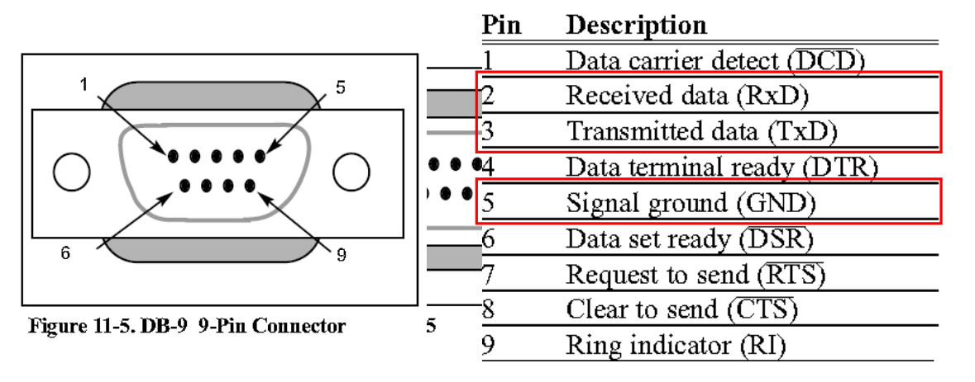

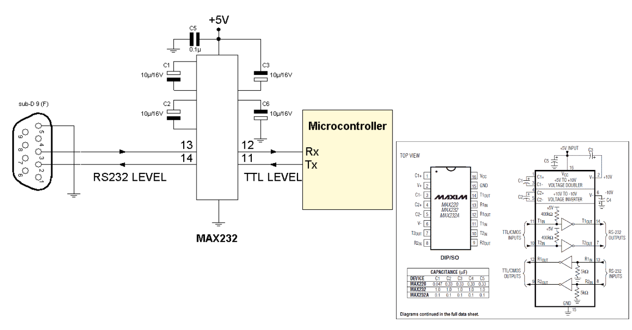

1. **INITIAL/MODIFIED/DEVELOPED CODE OF TASK 1/A**

Task 1 C code:

#define F_CPU 8000000UL

#include <avr/io.h>

#include <util/delay.h>

#include <util/setbaud.h>

#define BAUD 9600

#include <stdio.h>

void read_adc(void);// Function Declarations

void adc_init(void);

void USART_init( unsigned intubrr);

void USART_tx_string( char *data );

volatile unsigned intadc_temp;

char outs[20];

//initializes the USART (RS232 interface)

void USART_init(void) {

UBRR0H = (uint8_t)(BAUD_PRESCALLER >> 8);

UBRR0L = (uint8_t)(BAUD_PRESCALLER);

UCSR0B = (1 << TXEN0)|(1<<RXEN0); // Enable receiver, transmitter & RX interrupt

//asynchronous 8 N 1

UCSR0C = (0 << UMSEL1) |

(0 << UMSEL0) | // 00 async operation, 01 synch operation

(0 << UPM10) | // Parity -0 Disabled, 0 Reserved, 1 Enabled Even, 1 Enabled

(0 << UPM00) | // Parity -0 Disabled, 1 Reserved, 0 Enabled Even, 1 Enabled

(0 << USBS0) |// stop Bits -0 = 1bit 1 = 2bit

(1 << UCSZ10) |// 8 Data bits

(1 << UCSZ00) |//

(0 << UCPOL0);// for Synch Mode only -clock polarity

}

//send some data to the serial port

void USART_tx_string( char *data ) {

while ((*data != '\0')) {

while (!(UCSR0A & (1 <<UDRE0)))

UDR0 = *data;

data++;

}

}

unsigned char USART_Receive( void )

{

//wait for data to be received

while ( !(UCSR0A & (!<<RXC)))

//get and return received data from buffer

return UDR0;

}

void adc_init(void){

/** Setup and enable ADC **/

ADMUX = (0<<REFS1)| // Reference Selection Bits

(1<<REFS0)| // AVcc-external cap at AREF

(0<<ADLAR)| // ADC Left Adjust Result

(0<<MUX2)| // ANalogChannel Selection Bits

(1<<MUX1)| // ADC2 (PC2 PIN25)

(1<<MUX0);

ADCSRA = (1<<ADEN)|// ADC ENable

(0<<ADSC)| // ADC Start Conversion

(0<<ADATE)| // ADC Auto Trigger Enable

(0<<ADIF)|// ADC Interrupt Flag

(0<<ADIE)| // ADC Interrupt Enable

(1<<ADPS2)| // ADC PrescalerSelect Bits

(0<<ADPS1)|

(1<<ADPS0); // Select Channel

}

void read_adc(void) {

unsigned char i=4;

adc_temp= 0;

while (i--) {

ADCSRA |= (1<<ADSC);

while(ADCSRA & (1<<ADSC));

adc_temp+= ADC;

_delay_ms(50);

}

adc_temp= adc_temp/ 4;// Average a few samples

}

int main(void)

{

adc_init(); //initialize adc

USART_init(UBRR_9600); //initialize usart

_delay_ms(250); //wait 0.25 seconds

USART_tx_string("\r\nConnecteed!\r\n"); //display connected

_delay_ms(250); //wait 0.25 seconds

while (1) //do this until finished or broken

{

USART_tx_string("Hello World!!"); //display string

_delay_ms(1000); //wait 1 second

read_adc();

snprintf(outs, sizeof(outs), "%f\r\n", adc_temp); //print floating

USART_tx_string(outs);

_delay_ms(1000); //wait 1 second

read_adc();

snprintf(outs, sizeof(outs), "%3d\r\n", adc_temp); //print integer

USART_tx_string(outs);

_delay_ms(1000);

}

}

1. **DEVELOPED MODIFIED CODE OF TASK 2/A from TASK 1/A**

N/A

1. **SCHEMATICS**

N/A

1. **SCREENSHOTS OF EACH TASK OUTPUT (ATMEL STUDIO OUTPUT)**

Task 1:

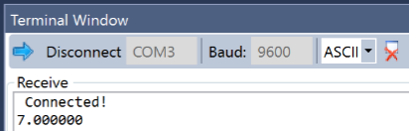



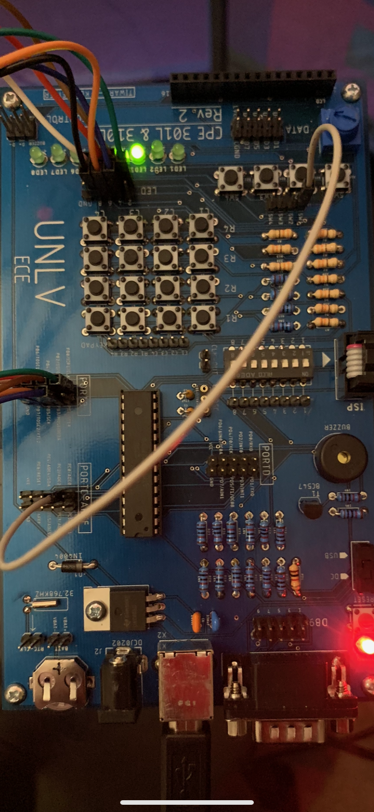

1. **SCREENSHOT OF EACH DEMO (BOARD SETUP)**
2. **VIDEO LINKS OF EACH DEMO**

N/A

1. **GITHUB LINK OF THIS DA**

https://github.com/tylergardenhire/submission_projects.git

**Student Academic Misconduct Policy**

<http://studentconduct.unlv.edu/misconduct/policy.html>

“This assignment submission is my own, original work”.

TYLER GARDENHIRE